UAT Comments : April 18, 2016

**<MC> Point 1-3 will be completed by 30th June and related to Active Directory Integration.**

1. User Name / User ID / ESS log in – this is not done
2. Change the Approver coding- this is not done
3. Direct link between the ESS Employee master data and the approver list.- this is not done
4. Expense Account master to be categorize as - OK
5. Business travel
6. Purchase requisition
7. Rearrange the view / table of the employee to look friendly and easy to understand when checking. -OK

* BP Currency / SAP Posting currency / Transaction currency/ Transaction amount / Exchange rate / Local amount and so on

1. The Transmitted details when the email notification is sent to the approver shows as follows: details transmitted is not correct. See below test performed 12.06.2016

<MC> Will be fixed

The 3rd column, (currency), change this to transaction currency followed by transaction amount and so on. This will give the approver an overview what he/she is about to approve, what currency and how much.

Preview on ESS of the approver.

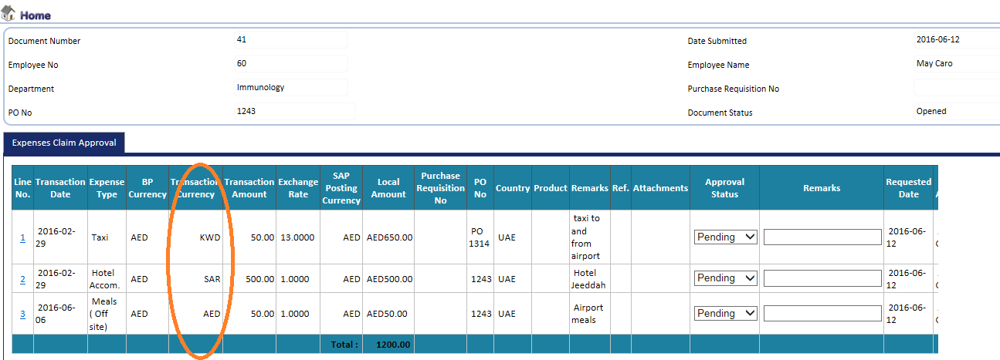

E-mail notification: Transaction currency transmitted is all AED

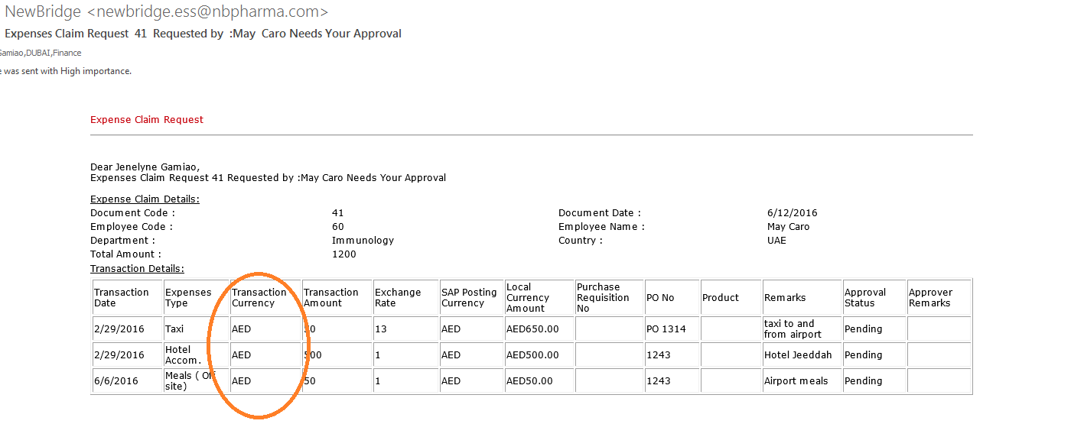

1. Changed the below in the approver’s view: Total amount should be the payable amount to the employee, not the total of all transaction currency.- OK
2. E-mail Notification when expense is approved or rejected does not contain the remarks of the approver. The comments of the approvers is on the approval history.

Journal entry generated when approving document 36 is as follows: JV number 305 and 306

ESS document number 41: with 3 lines, 2 of which were approved at the same time generated to Journal vouchers Journal vouchers 316 & 317.

<MC> Please re-check expense claims 43-45 – partially approved, all of them contain 3 lines – partially approved (2 lines) and partially rejected (1). Each expense claim creates one voucher for 2 lines approved.

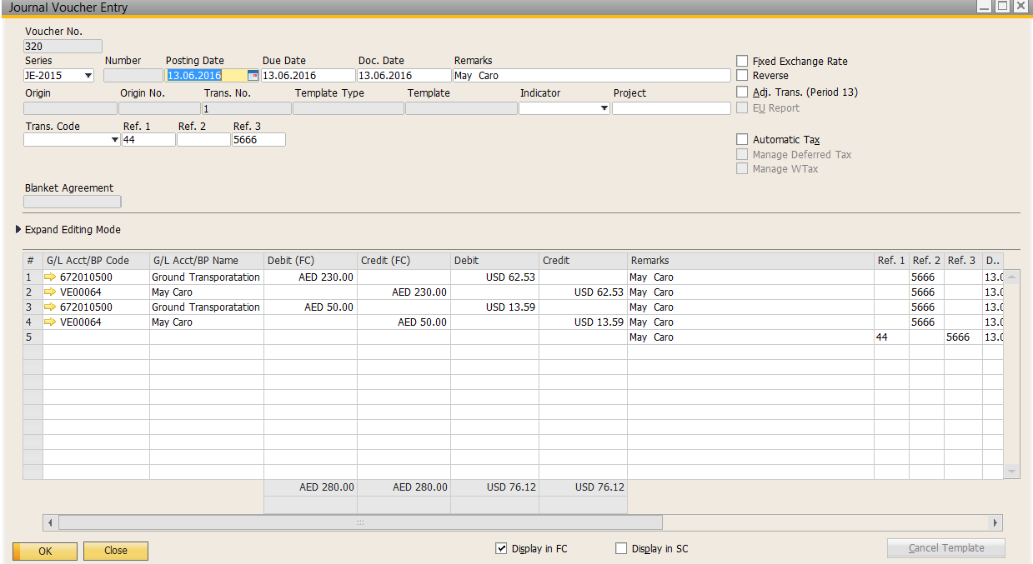

1. User view in ESS…..ok approval status is added
2. There is no control put in placed! Reimbursement #36 was has been approved earlier with the following current status. – not done.

<MC> By pressing the button “Submit” new request is not placed, however you are right, it sends the email. This will be fixed.

As per testing on 12 June, a partially approved expense reimbursements can still be reinitiated for approval. Document # 42 & 41

Approvers being notified by email as follows:

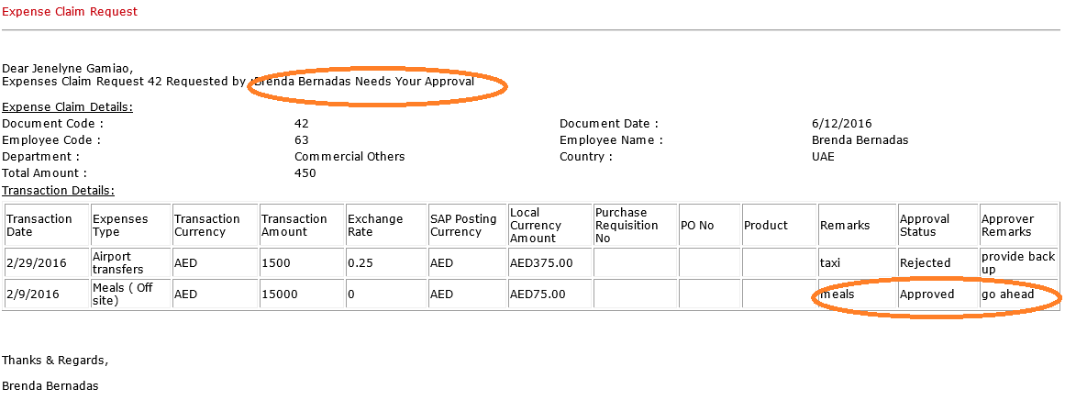



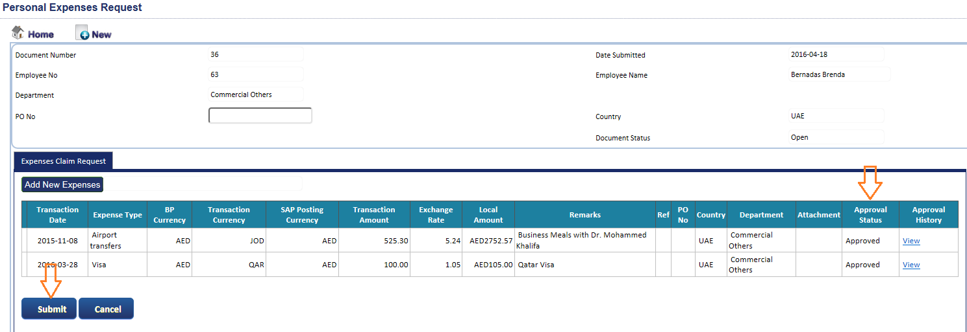

Is press the “submit” button….and BINGO!!!! Approver receiving another email notification for approval.



Though In the approvers log in, document 36 is not in the open list, however approvers would tend to find document 36 as per the notification received.

Once the document is approved, “submit” button should be disabled….no changes must be accepted

All rejected reimbursement should be have to have new or reinitiated ESS document.

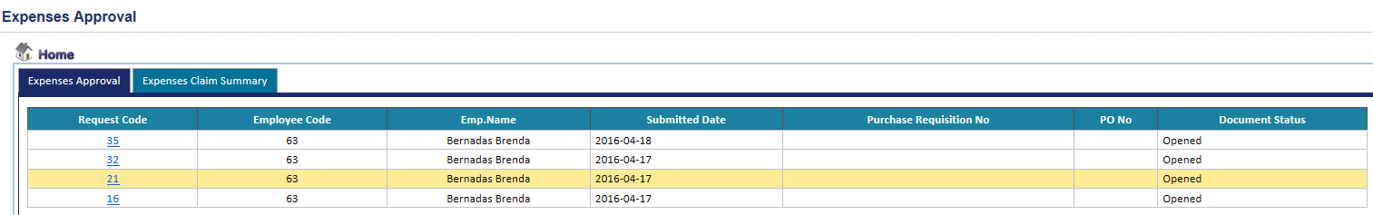

1. Document status is not changing in the approvers log in. – not done.

<MC> Document Status is not changing. It is either open or closed. The approval status is changed. See below

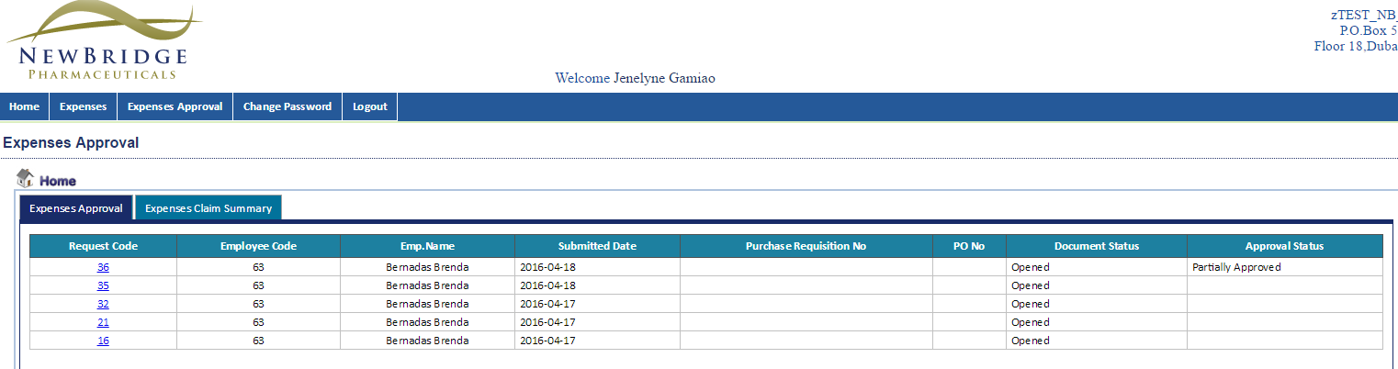

Below are taken from tab approved however status is still open

It should show status at every stage of the reimbursement.

* Open – as not approve
* Sent to approver or pending
* Approved
* Rejected

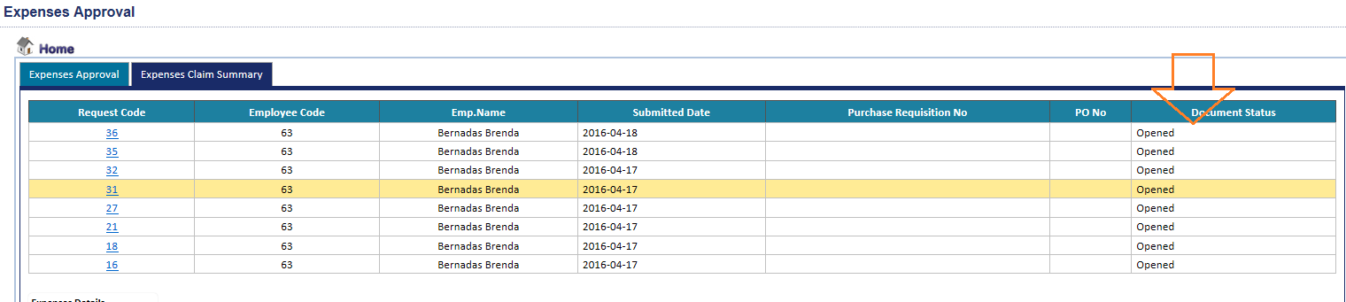

1. A user can add on a “fully approved” document…….This should not be the case at all times…. A fully approved document should be closed for any further modification or additions. Document 36 is fully approved request but has allowed me to add new expense type

<MC> Will be fixed

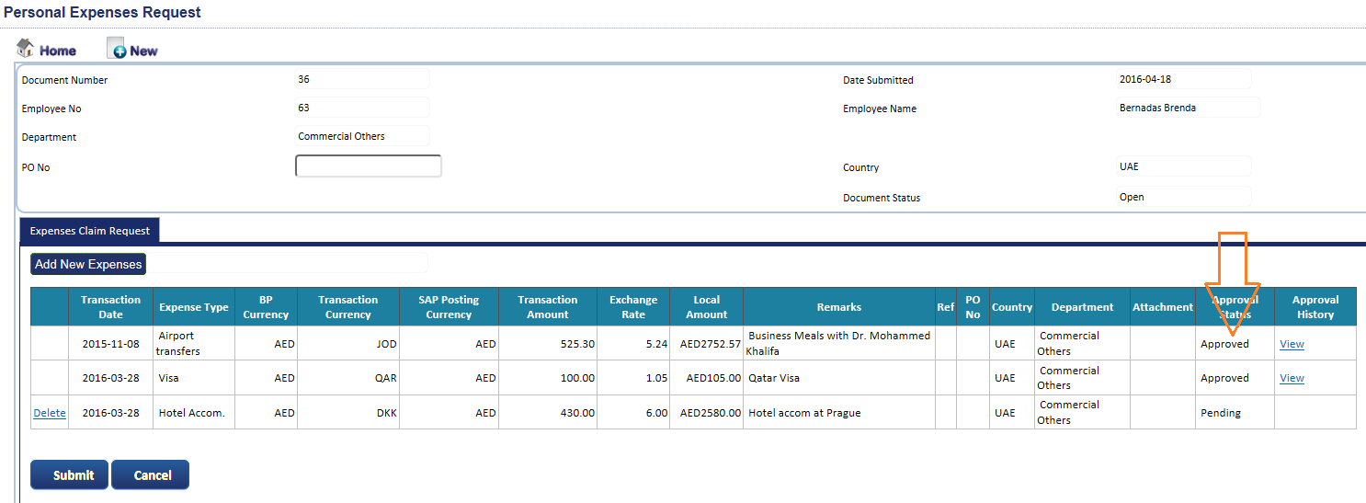

I will initiate the approval…..document # 36 has 2 approval, and 1 pending status….

I get an email notification as follows:



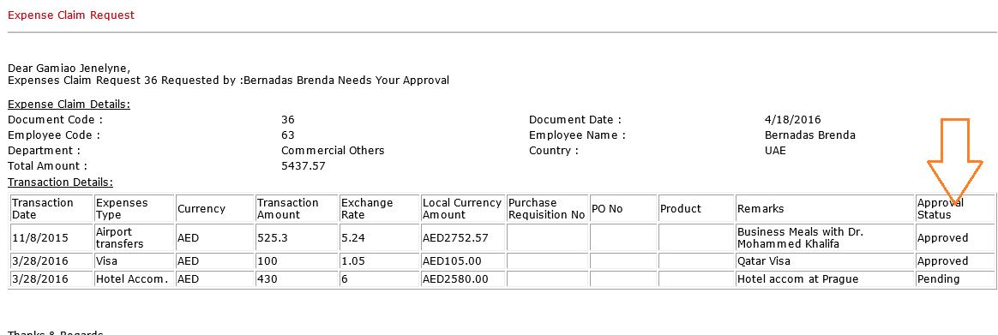

The approver view in ESS as follows:

Tab “Expenses Approval”

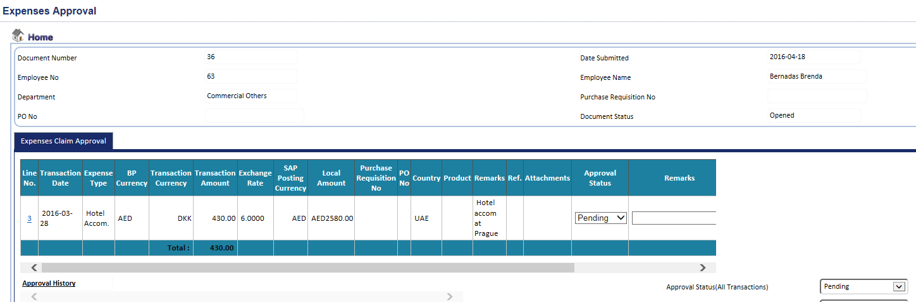

Tab “ Expense claim summary”….approved and pending are mixed and everywhere.

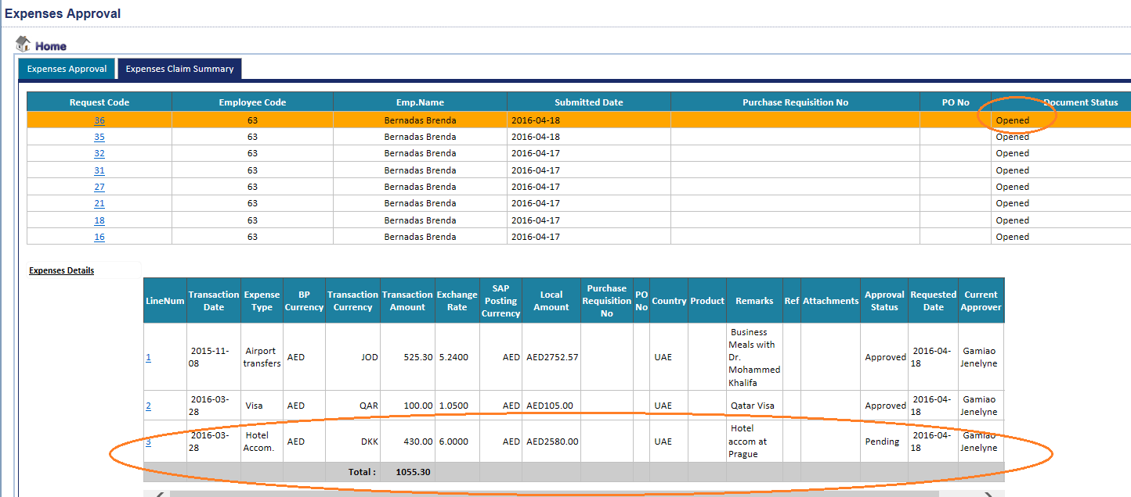

1. There are 2 lines on document # 36 that is approved as the time. I’m expecting SAP to generate 1 JV for the same……however SAP generated 2 JVs instead.. not done

The JV should appear in 1 JV with the following entry:

Debit – Ground transportation AED 2852.57

Debit – Other travel cost AED 105

Credit - VE000XXX- Brenda Bernadas AED 2,957.57

<MC> It can not be done as above. It is done in 1 JV as follows. This is to prevent unbalanced transactions error and be able to transfer all the details / references related to the expense

Debit – Ground transportation AED 2852.57

Credit - VE000XXX- Brenda Bernadas AED 2,852.57

Debit – Other travel cost AED 105

Credit - VE000XXX- Brenda Bernadas AED 105

1. Posting date in SAP should be the **approval date** not transaction date. Ok
2. Dimensions which are inactive in SAP still showing in ESS. All inactive dimensions in SAP should be automatically inactive in ESS. ESS and SAP should be synchronize. ***The effective to date should be considered. –***

**<MC> For Purchase Requisition the department is only on the header and the status (active / inactive) is checked against Submission Date. Country and Product on the header are not filtered because they will not be transferred on the lines.**

**On the expense lines Country and Product active / inactive status are checked against Transaction date.**

**For Personal expenses, on header only the Department status is checked. The validation for Country is done on the line level.**

***I have blocked Mkt, Halaven & UAE. Marketing and Halaven is inactive in ESS but UAE is active- please check***

Scenario 1: No check in the active

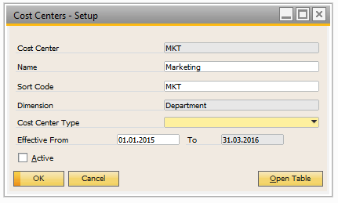

MKT is still available in ESS….

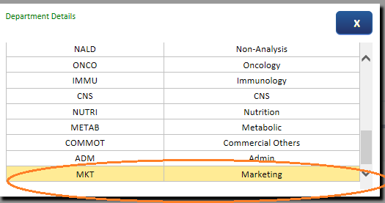

Scenario 2: with check in the active

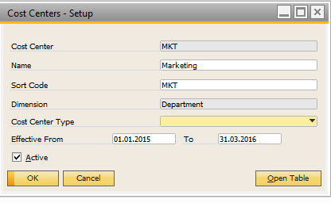

MKT dimension is still available.

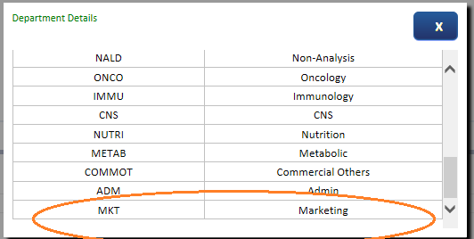

1. Posting in multiple dimensions

The user/employee will see the below dimensions **Country & Department**

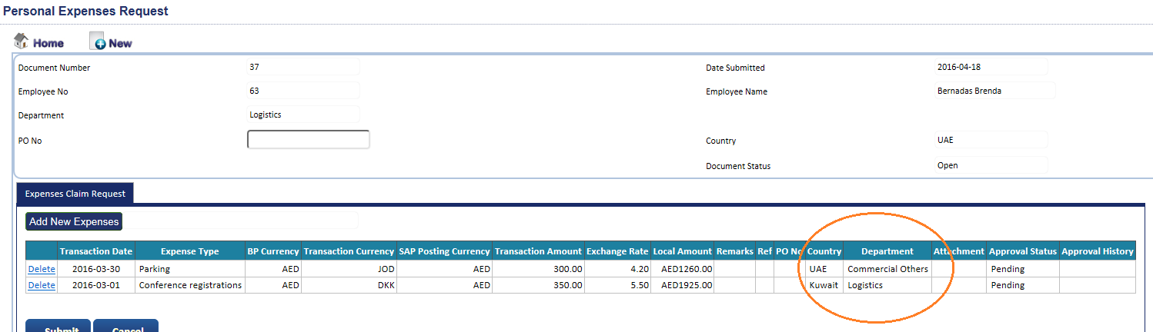

In the manager’s access does not show the ***department.***

***All dimensions should appear in both the user/employee and the approver/manager.***

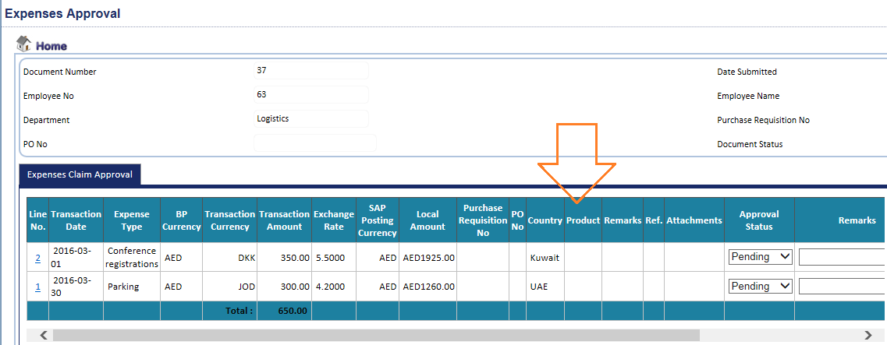

1. There is no reference number linked between the documents in ESS and when posted in SAP.

These should be filled atleast in reference # 1 = Brenda Bernadas document# 36 and so on. ok

**20. Kindly use the attached latest ESS data**



**21. When the approver approves the reimbursements, the email notification sent to the employee looks like this. ok**

**22. Printing reports and /or approve reimbursements is not available**

**<MC> Noted, will be fixed.**

23. In purchase requisition expense, we need the **PR# to be mandatory and the product as drop down selection not by default Abstral.**

**<MC> It is mandatory on the line level. Please re-check.**

**24. All dimensions should be made available with the employee and the approver**

**<MC> Noted**

**Employee access has country, department and product**

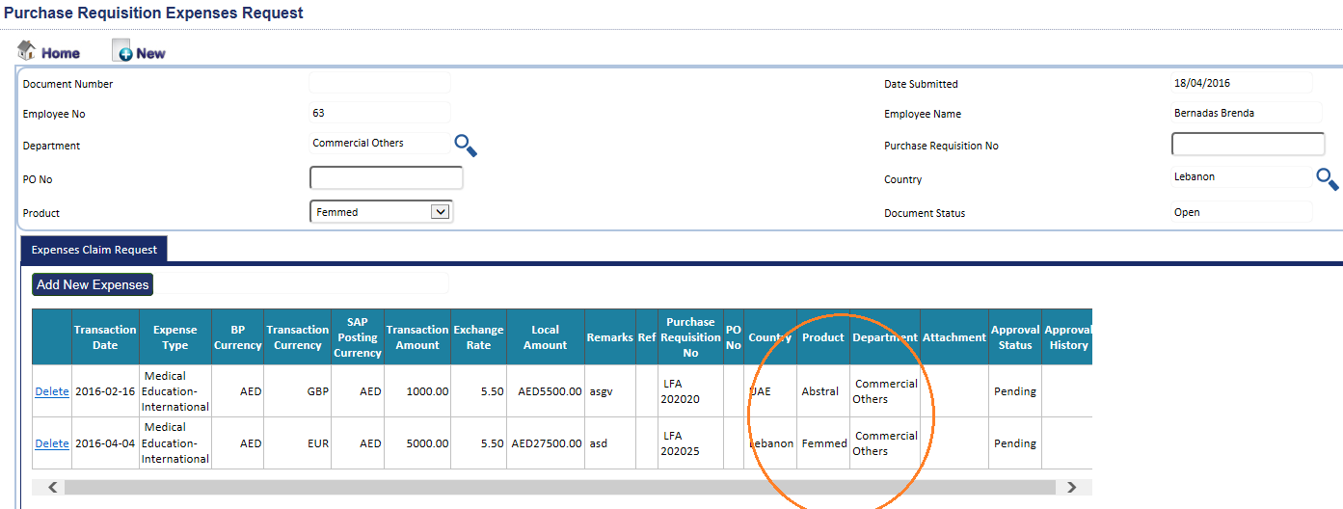

**Manager Access: does not have the department**

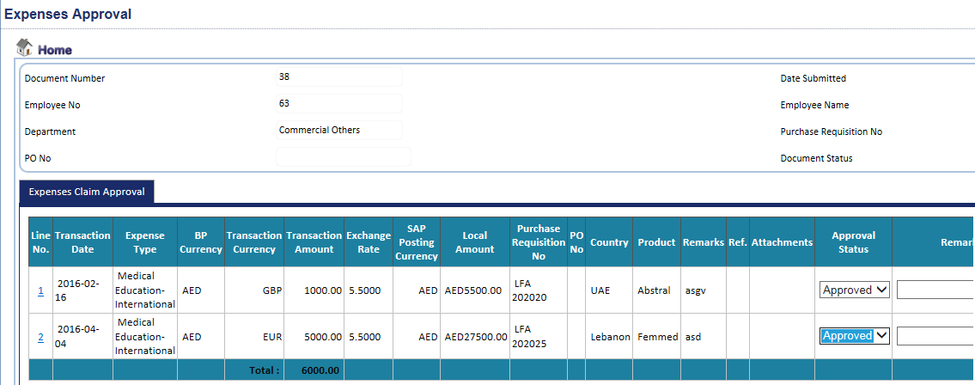

**25. How is the amount of reimbursements deducted / tracked or monitored from the PR budget?**

**<MC> It will not deducted from budget. Please refer to the blueprint.**